# Design Outline:

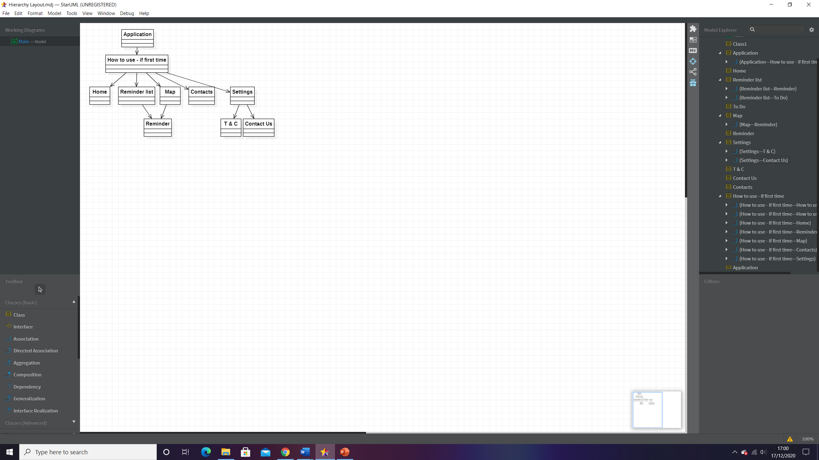When the design phase was first started the initial step taken was to plan how the different pages of the application would link together, this was done through a hierarchy diagram. The pages first thought up were Home, Reminder List, Map, Contacts, Settings, T&C, Contact Us and Reminder.

A how to use page which would give a brief summary on how the application functions for new users, to add to accessibility this could have an option to display every time if the user wishes to which would be of greater use for older individuals and those suffering from memory related conditions.

The next part of the design was to create wireframes for each page to give a general overview of how each one may look. This is something that will be aimed for during the creation of the artefact however changes may need to occur based on testing/functionality.

## Wireframes:

The Home Screen will be the first thing a user will see and because of this most of the important information the user would immediately want should be placed on it. The logo is placed top left as this is generally the first thing users will see. A large record reminder button is placed in the centre, as the main functionality of the app is to take the users speech and convert it into a usable reminder it seemed important to have this be the main focus as soon as the user starts the app. For added functionality a write reminder text box can be used if you’re unable to record your voice. Upcoming reminders show the most immediate reminders coming up or potentially reminders for that day. At the bottom is the navigation bar allowing the user to access other pages they may need. Finally placed top right is a button that takes the user to the settings screen, this has placed top right out of the way as most users will be unlikely to need it in their normal day to day use.

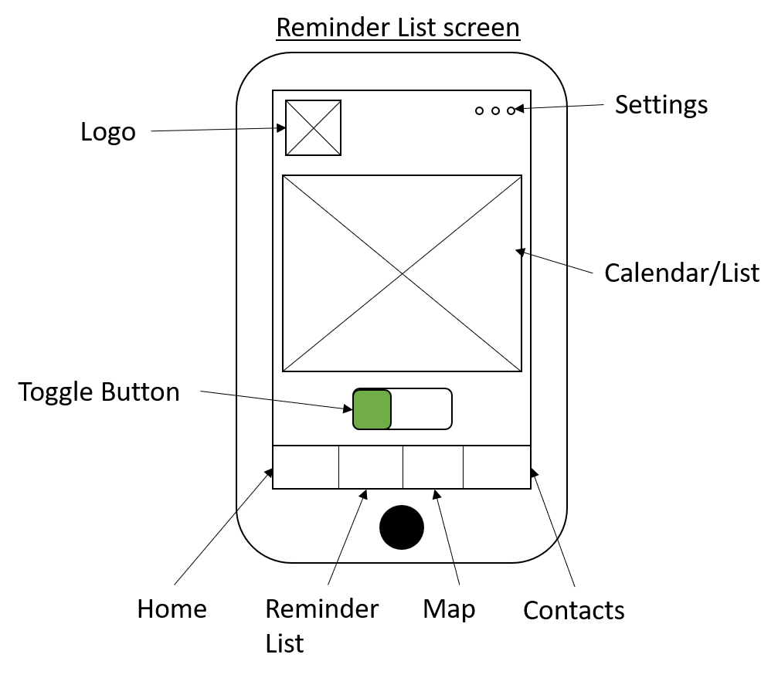

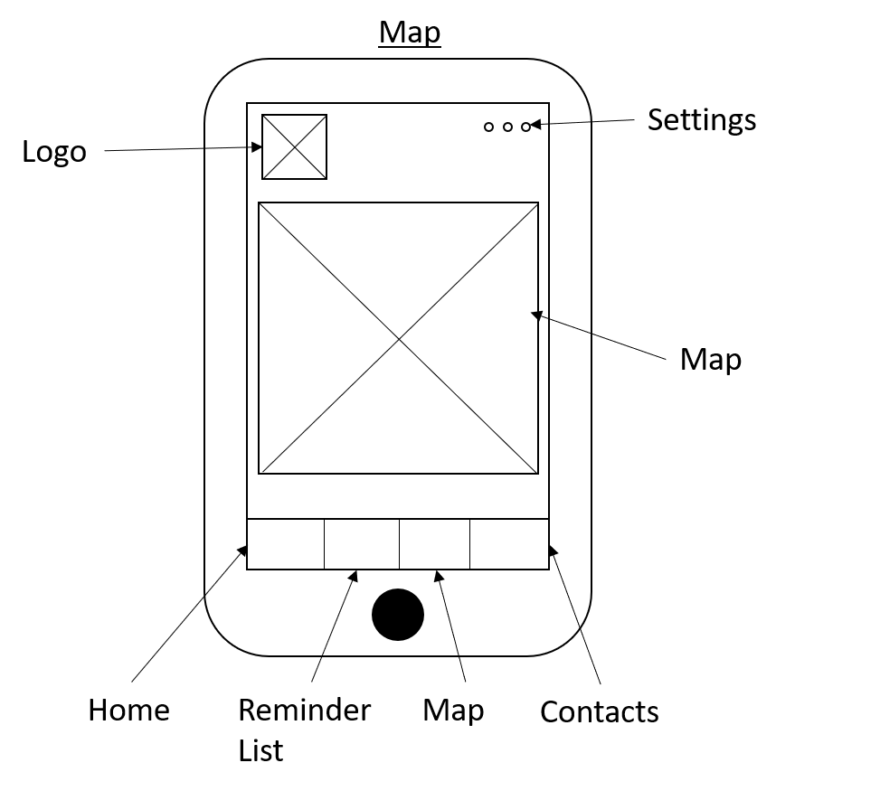The reminders list screen follows a similar layout to home, a calendar is placed in the centre allowing the user to see all upcoming reminders the user has set, a toggle button can be pressed that changes this calendar to a simple list if the user just wants to see the reminders in a different format. An individual reminder can be pressed which will take you to the reminder screen.

The map screen shows a map (likely using the google maps API) to the user, this will show where a specific reminder is set if this is applicable e.g., doctors’ appointment at the local GP. Once again pressing an individual reminder will take you to the screen for more information on that reminder.

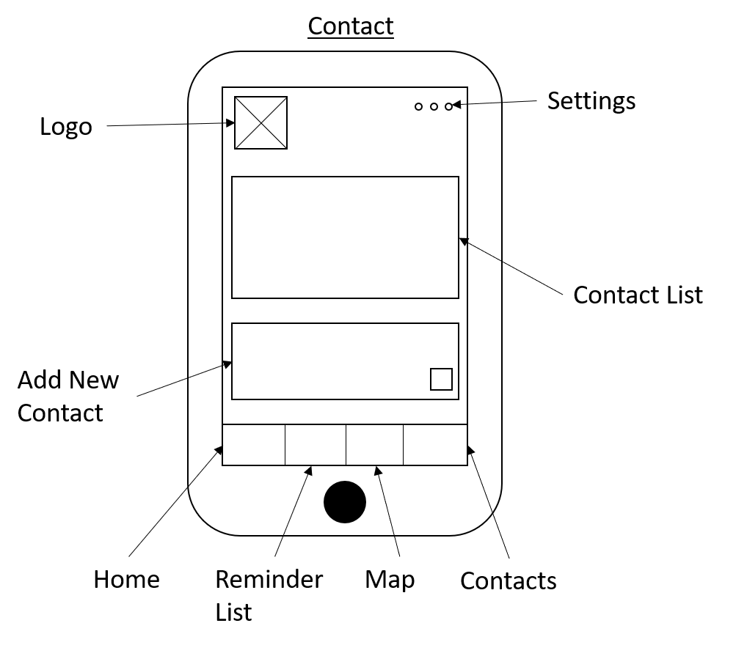

The Contact screen allows users to add/remove contacts, these can then be linked through reminders to allow for ease of contacting them if they need to for example a reminder called “Call mom at 13:00” could bring up the contact list at the time to allow for ease of use.

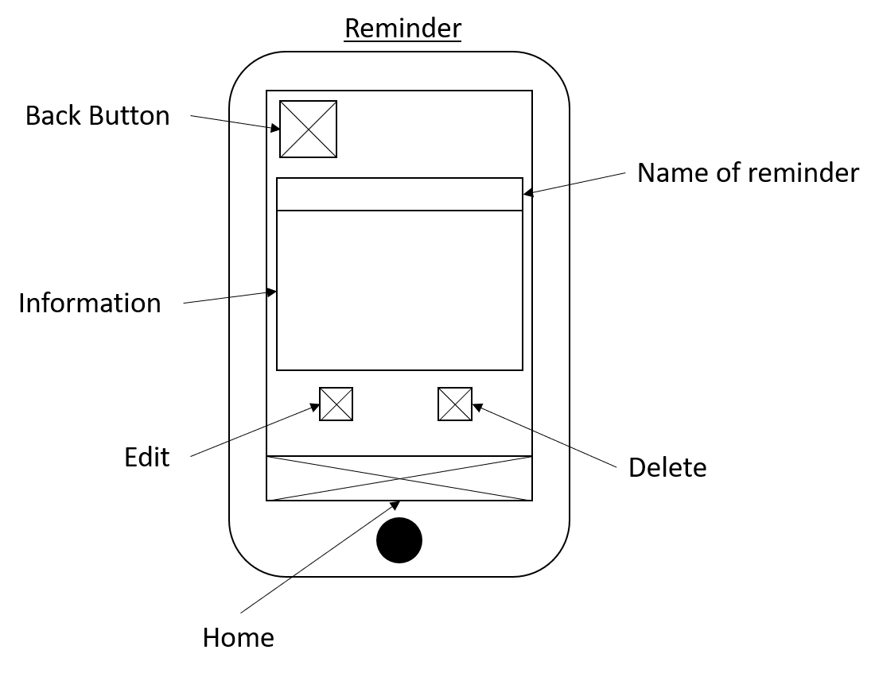

The Reminder screen shows the user all relevant information about a specific reminder along with an option to delete or edit it. A back button allows them to return to the page they came from and the home button at the bottom allows the user to go back to the original start page.

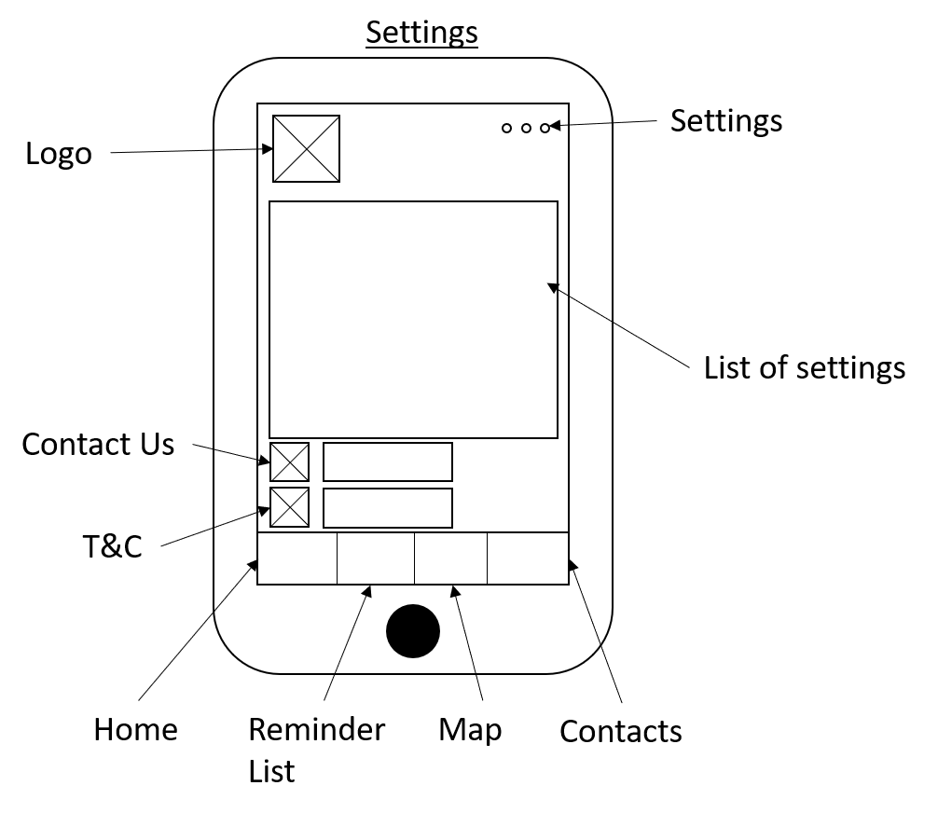

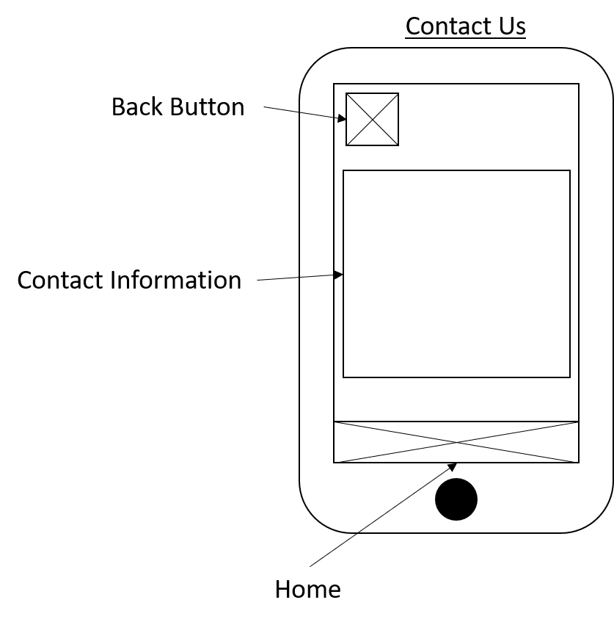The Settings page allows the user to change certain settings on the application, it also allows them to view the terms and conditions and contact page for the creator.

The Contact Us page just allows the user to contact the creator of the application, a back button will take the user back to the settings page and the home button will take them to the home screen.

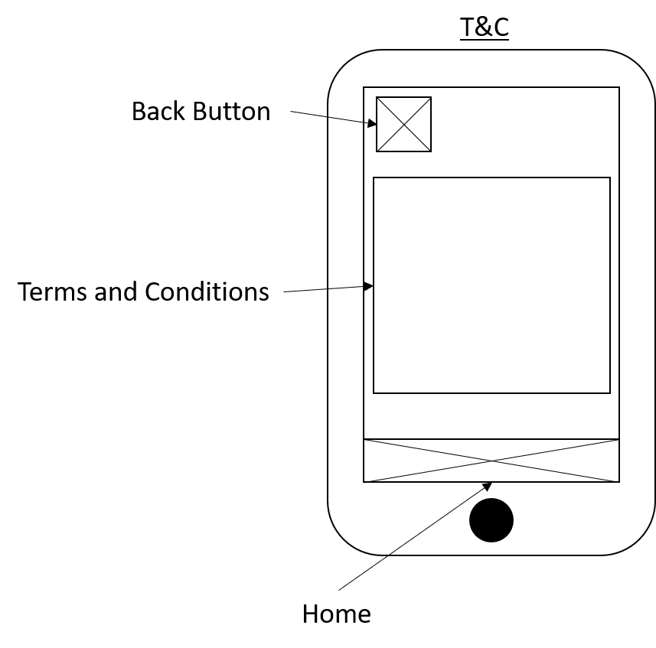The T&C page is very similar to the Contact Us page, the only difference being that it shows the terms and conditions of using the app instead. The back button also takes the user back to the settings screen.

## Potential Functionality:

Speech recognition is highly likely to be used within this application, most likely being incorporated through the Android Speech Recognition API. This will be used on the home page to record the users voice in order to make reminders. At a basic level this could work through a list of key words/frequently used commands with user training in order to take reminders. This would be used like the following “Make an **appointment** at **Doctors** on **Tuesday** at **5pm**” where certain keywords are selected to make a reminder with a date and time, this would correspond to a list of keywords. At a more advanced level the use of speech analysis and machine learning could be incorporated in order to learn from the users own vocabulary, which would allow for a greater range of keywords to be used, however this is dependant on how feasible it is within the timeframe.

Automatic reminders through the use of machine learning is another potential functionality of the application. This would work wherein a pattern or trend of reminders is recognised within the app and further reminders are set, this could be a reminder to “brush teeth at 8am” being set everyday by the user, and the recognising the trend to set more. A very basic version of this could be done through simple if statements however applying actual machine learning will likely require the use of existing API’s.

## Design Specification:

Aesthetics – The application should be simply laid out and easy to follow for those new to using technology. All relevant information should be immediately available to the user, and anything not immediately available must be easy to find. Colours should be clear and contrasting with a consistent colour scheme used. The fonts used within the application should also be clear, readable and large enough so as to not cause eye strain, these fonts ideally should be based around Arial, Georgia or Verdana. Times or Times New Roman could also potentially be used however due to their usage primarily being in news and publication they may not be the most applicable for an app-based artefact.

Target Audience – This artefact will be primarily designed towards users who struggle with memory in day-to-day tasks, this can include general forgetfulness however also applies to effects of old age on memory as well as those afflicted by memory related conditions such as Dementia and Alzheimer’s.

Function – The function of the artefact is to allow the user to create reminders for themselves to help with day-to-day tasks this can range from shopping lists, appointments or day to day tasks around the house. This can either work based on speech recognition or by the user manually entering reminders. These reminders will then be shown to a user through a notification closer to the time set in the reminder. The use of AI and learning algorithms can be used to increase the potential effectiveness of the artefact by being able to recognise certain patterns or routines in the user’s behaviour in creating reminders in order to dynamically create more.

Technologies – The chosen technologies will most likely be Java as the programming language and created within Android Studio. SQL will have to be used for any database work. Google maps API and Android speech to text API will also have to be used when creating this artefact.

## Test Plan:

•75% or higher of user responses through a survey should not find colours to be off putting or undesirable.

•90% or higher of user responses should find all text on the application easily readable.

•80% or higher of participants testing the app should use the app every day or state they wished to use the app every day, this is in order to see if the app fits it purpose of being capable of creating reminders for day-to-day use.

•95% or more of user responses should indicate that it was easy to find all pages in use.

•A reminder should be recorded in 3 or less interactions with the screen (taps) in order to be streamlined.

•Deleting a reminder should be done in 4 or less interactions with the screen (taps).

•Editing a reminder should be done in 7 or less interactions with the screen (taps).

•Viewing a reminder should be done in 3 or less interactions with the screen (taps).

•Viewing the map should be done in 2 or less interactions with the screen (taps).

•Settings should be used the least frequently by test participants.

•Home should be used the most frequently by test participants.